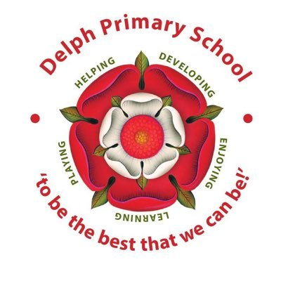
Year 5 Class Newsletter
Term: Autumn Term 1 2026 Topic: Ancient Egypt
1

English: This term in English we will be developing our diary writing and recount writing skills. Pupils will learn about the effective use of figurative language, such as similes, metaphors and personification. Much of the learning will link to the Whole Class Reading text which is ‘The Imaginary’ by A.F. Harold.  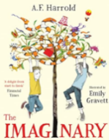  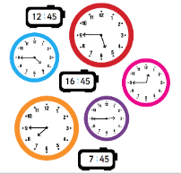  Mathematics: In Mathematics we will be tackling place value, addition, subtraction, multiplication and division. Over the half term, ask your children about this key vocabulary linked to this learning:  Roman numerals  Partitioning  Part-whole model  Rounding  Multiples  Common multiples  Factors  Common factors  Prime numbers  Square numbers  Cube numbers  Science: In Science this term, we will develop our Chemistry skills by learning about materials, including the process of mixing and separation, sieving, filtering, dissolving and evaporation.  Humanities: In Humanities we will be studying the wonderfully exciting Ancient Egyptian times.  PE: Our PE days are Wednesday and Friday. In PE this term we will be developing our orienteering skills (Wednesdays) and investigating invasion games skills through tag rugby (Fridays). Pupils will need both indoor and outdoor PE kits in school. PE kits can be left in school in a small drawstring bag. Please do not send large bags or backpacks as they do not fit in the lockers.  Other subjects: In Computing we will learn about computer systems and searching and in RE we will learn about Humanism and codes for living. DT, French and Music will continue to be taught too. | How you can help at home  - New Spelling Bee words will be sent home to be tested on in the last week of the half term  - Home Learning is set on Google Classrooms. There will be 6 pieces to be completed by Wednesday 21st October. A showcase will take place in school.  - Use Google Classroom to submit home learning tasks if preferred.  - Login to TT Rockstars regularly to develop times table skills and fluency.  - Ensure your child reads regularly to an adult. By reading with your child, you are not just helping them to develop their fluency but also their understanding and inference skills. Books can be signed out of the Year 5 class library for the children to take home.  - Talk to your children about how they can raise their independence. They have access to the ‘Can We Talk’ box in school, should they wish to talk to a trusted adult of their choice.  Visits and Visitors  This term we will visit Bolton Museum to enhance our learning about the Ancient Egyptians. Information about this will be sent on a different letter.  Dates for the Class Diary  15.10.26 Bolton Museum Trip  21.10.26 Home Learning due for the homework showcase  22.10.26 School breaks up for half term  Mrs Downey will teach the class on Mondays, Tuesdays, Wednesdays and Thursdays and Mrs Mair will teach the class on Fridays. Mrs Bebbington will provide support in class throughout the week.  We look forward to a wonderful half term together!
Visit our school website to find out more about the learning taking place this term: www.delphprimary.co.uk

